**Name: Syeda Tabinda Hassan Abidi**

**Roll no: BM-19059**

**Course Code: BM-406**

**Instructor: Dr: Eraj Humayun**

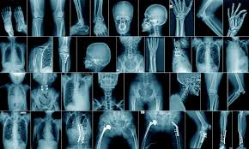

BIOMEDICAL IMAGING LAB MANUAL

LAB#9

Object: *Applying filters to an image*

**(a) Source Code:**

bw=imread("Tab.png");

bw2=imcomplement(bw);

imshowpair(bw,bw2,'montage')

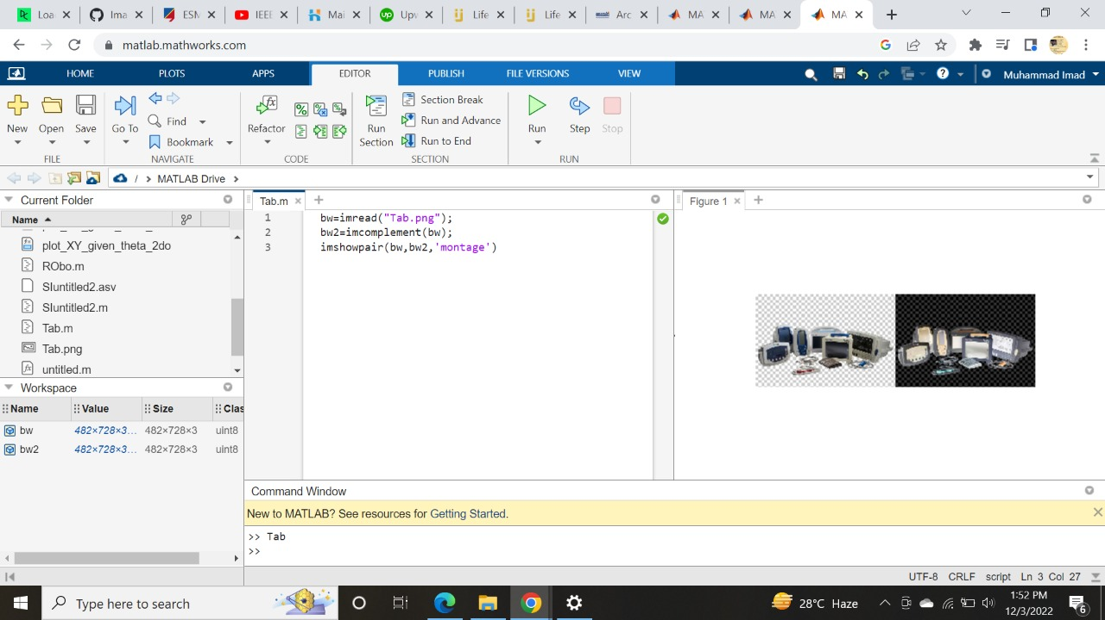

**(b)Source code:**

bw=imread("humanoid.png.jpg");

bw2=imcomplement(bw);

imshowpair(bw,bw2,'montage')

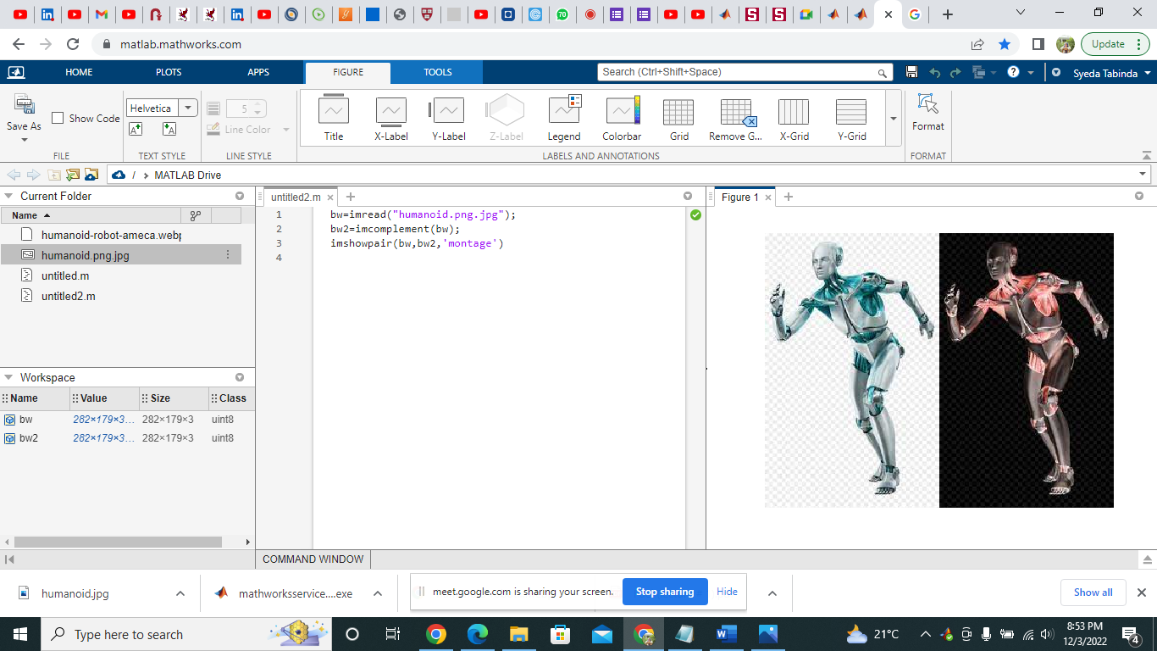

**(c)Source code:**

bw=imread("snakerobot.jpg");

bw2=imcomplement(bw);

imshowpair(bw,bw2,'montage')

